Farming Research

**Your Task**: Research 5 key points that provides a description of what the farmer does and have them identify at least 3 key “selling points” of each. *For example, an organic farmer grows food that is free from chemicals and non-organic fertilisers. The selling point is that they provide healthy foods*.

Brainstorm all the factors that might affect their business and categorise these factors as:

• beyond their control

• able to be controlled (i.e. prevented or initiated)

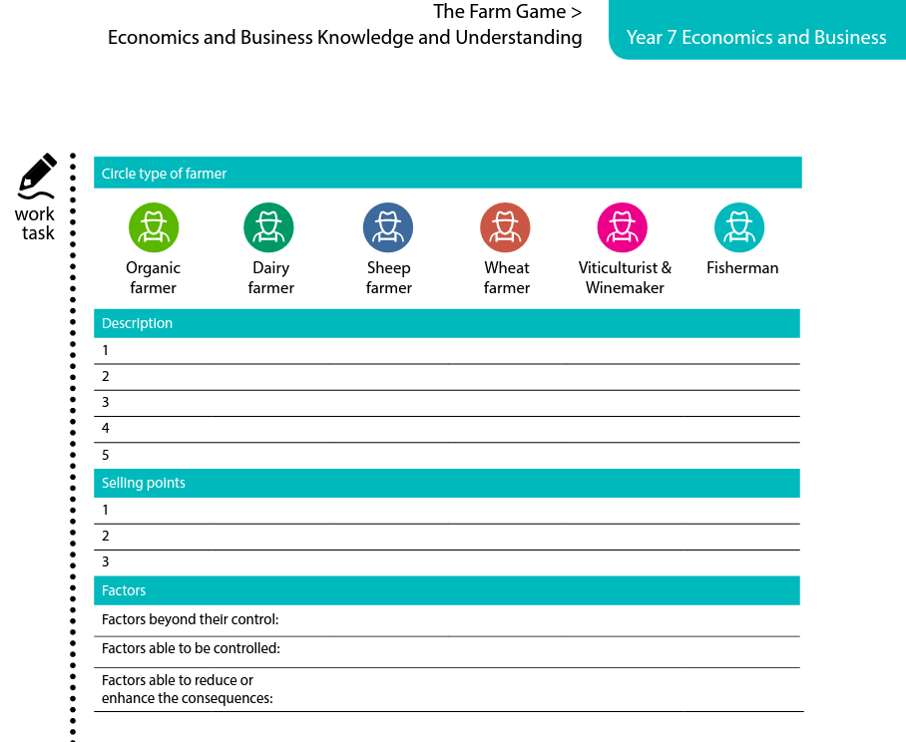 • able to reduce or enhance the consequences Examples are: particular types of weather and market forces. Record brainstorms on worksheet below.

*Once you have completed this you can present this information as a Power Point.*